Manuscripts Digital Repository
User Requirement Specification
Revision History

Rev. | Date | Description | Author | Review | Approval | Changes
0.2 | 15/06/2013 | Initial Draft | Narasimhan M.G. | M.A. Alwar, Venugopal |  | Initial Draft
0.3 | 28/06/2013 | Added Entity Designs | Narasimhan M.G. | M.A. Alwar, Venugopal |  | Added Entity Designs

Table of Contents

1 Introduction 4
.1.1 Overview 5
.1.2 The types of users and their usage 6
.1.3 Digitizer 6
.1.3.1 Scan and Digitize 7
.1.4 Librarian 7
.1.4.1 Catalog and Index 7
.1.5 Scholar 7
.1.5.1 Browse Libary 7
.1.5.2 Search/ Filter 7
.1.5.3 View Digital Manuscript 7
.1.5.4 Transcribe 8
.1.5.5 Proof-read Transcription 8
.1.6 Reviewer 8
.1.6.1 Review 8
.1.6.2 Annotate 8
.1.6.3 Approve 8
.1.7 Manager 8
.1.7.1 Allocate work 8
.1.7.2 Monitor Status 8
.1.8 Required Structures/Entities 8
.1.8.1 Digital Manuscript and Related Entities 9
.1.8.2 Physical Manuscript and Places of Origin 10
.1.8.3 Metadata 10

Introduction
The I-AIM Manuscripts Digital Repository (IAIM-MDR) will be a reservoir of manuscripts in scanned digital form. Manuscripts relating to Medical knowledge (mainly Ayurveda) will be collected by field operators from various parts of India (Karnataka, Kerala, Tamilnadu, Andhra, Maharashtra, North India etc). These will be scanned into computers and stored in digital form. The manuscript collectors may be enthusiasts, hobbyists, private collectors and designated Government/ Semi-Government/ Autonomous Institutions and their staff. The manuscripts thus collected may include any traditional field of knowledge. They may be in ancient, medieval or modern Indian Language Scripts.
The Govt. of Karnataka, Ayush department ( Under Dept. of Health & Family Welfare ) is sponsoring the project. The duration of the project is 2 years in 2 phases. In the first year (Phase I), the following goals are to be achieved.
- Catalog of about 15000 medical manuscripts.
- Digitized (scanned) versions of about 5000 manuscripts in the IAIM-MDR
- Indexed Library and Catalog of Manuscripts
- Search facility for identifying and extracting specific information
- Web Access to the MDR and access to content in electronic form.

Overview
The computer system is visualized as follows.
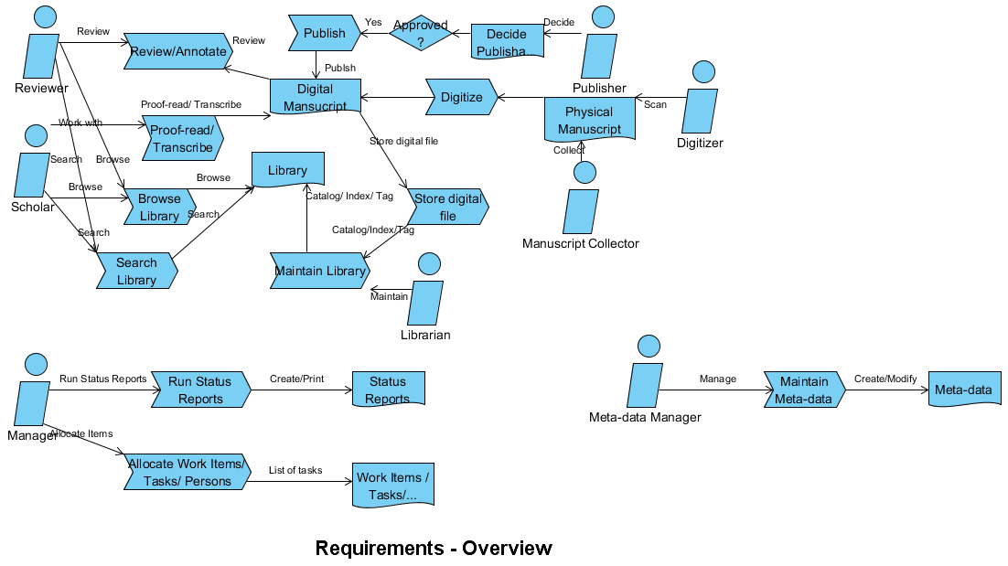
A Manuscript Collector collects Physical Manuscripts and delivers them to a Digitizer. The Digitizer scans and digitizes the Physical Manuscript and Stores an image file in standard formas specified by the National Manuscripts Mission (NMM) as a Digital Manuscript (DM). A Librarian then files, catalogs and indexes the Digital Manuscript into the Library (Manuscript Digital Repository). Scholars can Browse Library, Proof-Read and Transcribe the individual Digital Manuscript. A Reviewer then does a Review/ Annotate/ Approve process for the DM and the Transcript. After approval, the DM is Published in the MDR and available to other stakeholders. Other schlolars, editors and knowledge workers can Search, Browse Library, read, comment on and further annotate the DMs.
A Manager can Allocate Work to scholars, reviewers, publishers ,monitor the status of work, and Monitor Document Status. He/she also manages access permissions and levels to various types of users of the MDR. He/she will need various types of work-flow mechanisms and reports which assist in his/her work.
A Meta-Data manager creates and maintains tags and indexing terms which others can use to tag Digital Manuscripts. This is useful for Search of specific DMs or set of DMs.

The types of users and their usage
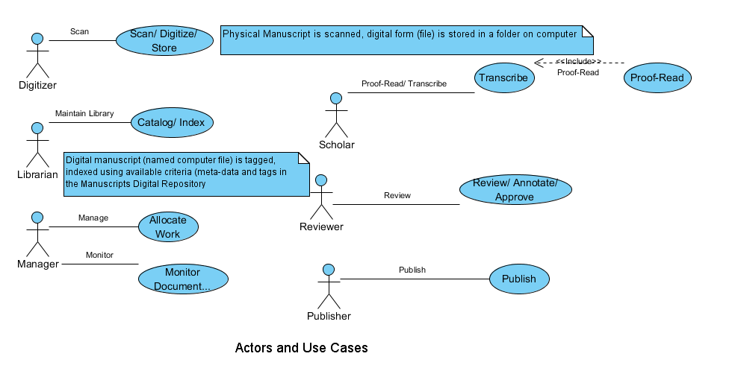
User Type | Use Case
Manuscript Collector | None
Digitizer | Scan and Digitize
Librarian | Catalog and Index
Scholar | Search/ Filter
 | Browse Library
 | View Digital Manuscript (DM)
 | Transcribe DM
 | Proof-read Transcription
Reviewer | Annotate Transcriptions
 | Comment on Transcriptions
 | Approve DM
Publisher | Publish DM
Manager | Allocate work
 | Monitor Status
Meta-data Manager | Create and Maintain Tags

Note that a user may play several roles. Same person can be a collector, digitizer and librarian. Similarly, a scholar can be a reviewer of some one else's DM. A Manager is likely to supervise the work of several other users.

Digitizer

Scan and Digitize
Physical Manuscripts are delivered to the Digitizer by the Manuscript Collector. The Digitizer has the required equipment to conver a physical manuscript to a DM, i.e. A scanner. The process of scanning and converting to DM is straight-forward. A JPEG image is the output of this process. This is stored on a computer. The number of such images per day depends on the the volume of physical manuscripts, the rate of scanning and the number of digitizers.
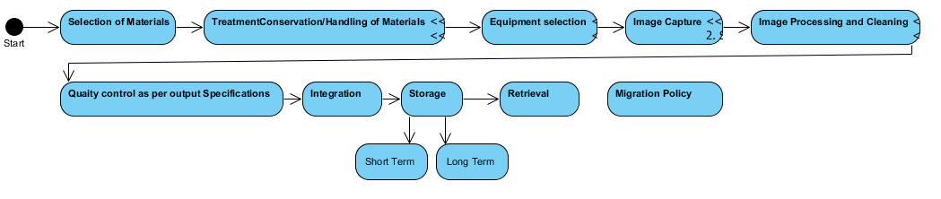

Librarian

Catalog and Index
The Librarian has access to the DMs through the LAN or directly. He/she launches the process to catalog a DM using a standard data form where the details like author, organization, title, bundle, and the electronic path to the DM (perhaps a URL) etc are filled in and filed. The system may file the NMM-standard techical and subject meta-data alone or it may also store the image file in the repository.

Scholar

Browse Libary
All the DMs in the library can be viewed on a screen. The list of DM s that is accessible by him/her (as defined by permissions given) are listed. Any item from the list of DMs can be chosen for a detailed view.

Search/ Filter
The scholar can choose to see only a few DMs by entering search and filter criteria. These can be fields like title, subject, author, scribe, organization etc. All DMs s are cataloged in the library according to a basic set of tags called subject meta-data and technical meta-data. These are as described in the NMM standard for manuscript digitization

View Digital Manuscript
The scholar may view any DM that is accessible by him/her. The view may be in a image viewer window, or an Editor window with 2 panes – image pane and transcription pane.

Transcribe
The scholar who understands a script and language can tarnscribe the contents into another langueg and/or script. It can be done in a 2-pane editor which has image view and normal editor panes.

Proof-read Transcription
Transcriptions created for a DM can be proof-read by another scholar. Access permission have to given correctlu to scholars who can review work.

Reviewer
A reviewer is a scholar who can review the content of a DM and its transcriptions.

Review
The reviewer can create commentaries for a tarnscription, a DM or both. The commentaries can be in the nature of essays, critiques and observations on the content, style, scribe particulars, history, region and so on.

Annotate
He/she can also create annotations for the DM and transcripts. They can refer to particular items, sentences, words, passages, individual aksharas etc.

Approve
When the reviewer is satisfied with the status of the DM, he/she can aprove it for publication. It will be published and available to the general users of the Library for further views/browsing.

Manager
A manager supervises digitizers, scholars and librarians. This role may or may not be always active. But it is useful to have such a role in the organization.

Allocate work
The manager creates and allocates work items for his/her staff with schedules and work rates. These work items are then delivered to the staff.

Monitor Status
The status of DMs are marked as In Library, Transcribed, Proof-read, Published etc. Reports can be obtained regarding the numbers of DMs that are tarnscribed in a duration, proof-read etc.

Required Structures/Entities
To address the scenarios described above, following entities have been designed.

Digital Manuscript and Related Entities

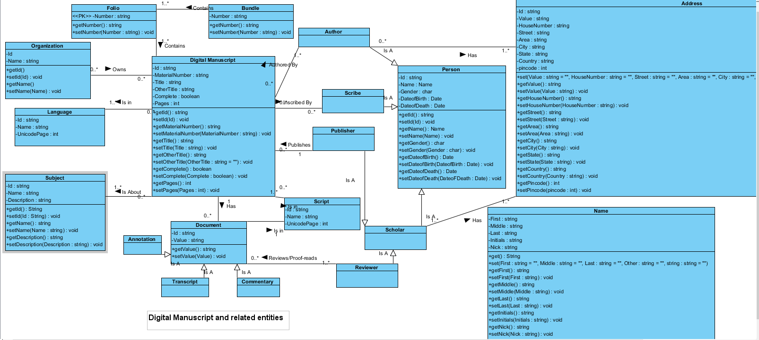

Entities are in italics below.

A Digital Manuscript (DM) belongs to a Folio. A Folio belongs to a Bundle. An Organization owns a DM.
A Person has a Name and one or more Addresses.
A DM is Authored By an Author. It is inscribed By a Scribe. It is about a Subject. It is in a Language and in a Script.
As it gets examined by A Scholar, it can be described by means of a Transcript, Commentary and Annotation. All of these are Documents attached to the DM. A Reviewer can also prepare such documents, mainly Commentaries and Annotations.
After review, proof-reading and approval, the DM can be published by a Publisher, along with its attached transcripts, commentaries and annotations.
Subjects can belong to other Subjects, with a Knowledge Tree Hierarchy. There can be one root node and several other child nodes, their child nodes and so on.

Physical Manuscript and Places of Origin

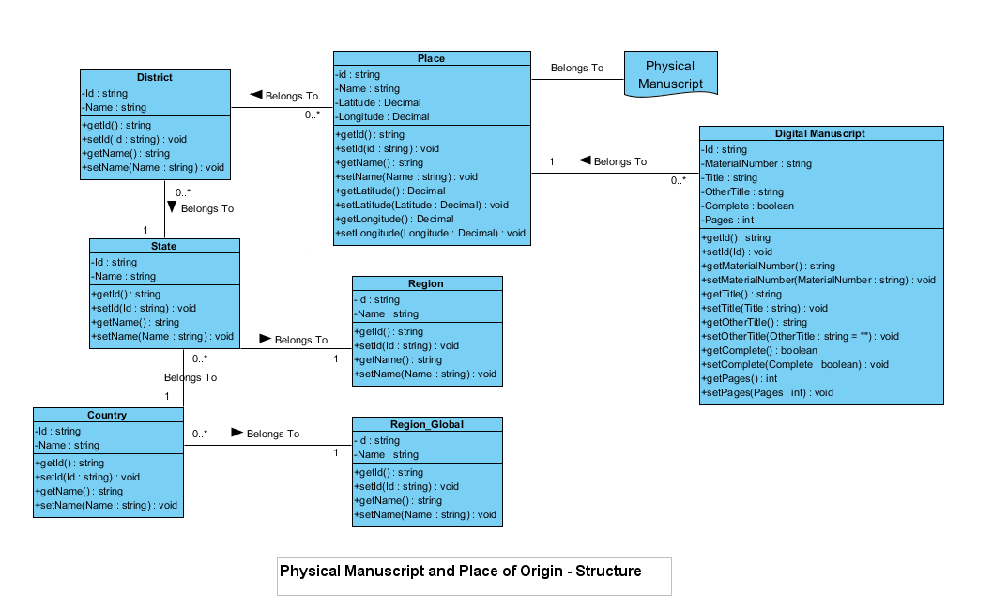

A Physical Manuscript belongs to a Place and the place can be a village, town or city, which in turn belongs to a District. The district belongs to a State and the state to a Region. The state also belongs to a Country. The country belongs to a Region_Global.

Metadata
Metadata is the descriptor or property of a DM. These are realized as Tags. These are additional attributes of a DM, apart from the core attributes like Title, Subject, Author etc. Tags can be created and maintained by the Metadata Manager. Any available Tag can be attached to a DM by a scholar, reviewer or author. Tags can belong to other tags, creating a tag hierarchy. 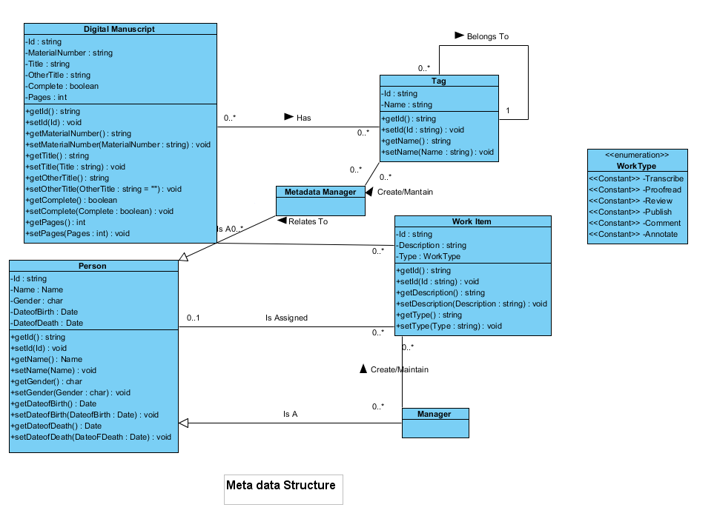
When searching for DMs, a scholar can construct search filters which include the core attributes as well as tags. The filter can express conditions such as "all DMs which have author Caraka, title containing 'medicine', subject surgery, and tags silver & gold".

Work Items can be created by a Manager and assigned to staff. These can be then monitored for status, reassigned so that it reaches some expected final state.

